Christus Lutheran Church

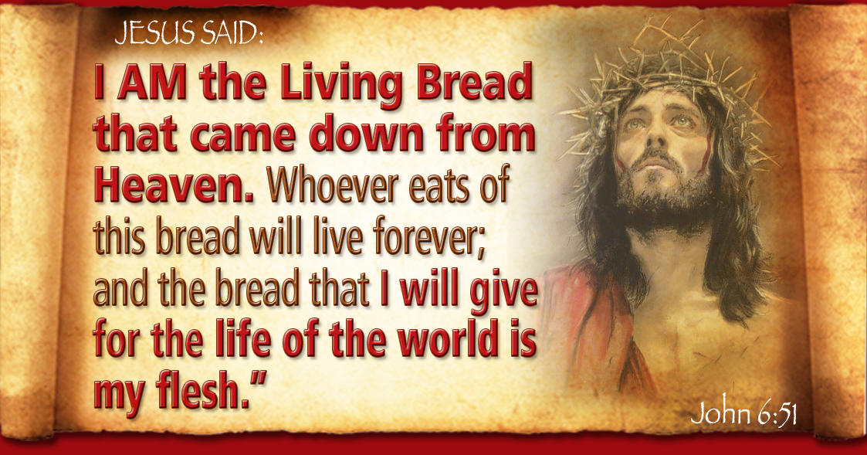

“Take; this is my body…
This is my blood of the covenant, which is poured out for many.”

Maundy Thursday
March 28, 2024 – 12:10pm
Large Print Complete

PRELUDE Ericka Shelton
Stand
HYMN: What Feast of Love WOV #701, v.1,3

1 What feast of love is offered here,
what banquet come from heaven?
What food of everlasting life,
what gracious gift is given?
This, this is Christ the King,
the bread come down from heaven,
Oh, taste and see and sing!
How sweet the manna given!

3 What wine of love is offered here,
what holy drink from heaven?
What stream of everlasting life,
what precious blood is given?
This, this is Christ the King,
forgiveness sent from heaven.
Oh, taste and see and sing!
The Son of God is given!

Be Seated
SERMON

INSTRUCTION

CONFESSION & ABSOLUTION
P: God seeks those who will worship Him in spirit and truth. Let us therefore confess the truth.
Kneel as you are able, or remain seated - Silence for reflection
P: God of mercy,
C: I confess that I am sinful and I have an unclean heart. Added to all my sins is my presumption upon your mercy and forgiveness. Show me that I deserve only punishment and condemnation, so that I might truly treasure your grace, and trust it entirely, both for forgiveness and a changed life. Amen
P: Your heavenly Father looks upon you in mercy, and by the blood of his beloved Son, Jesus Christ, forgives you all your sins. Rise to live in newness of life.
C: Amen; thanks be to God for his mercy and grace

Stand
PEACE
P: “We have peace with God through our Lord Jesus Christ.” [Romans 5:1] May this peace be with you all.
C: And also with you.
Share a sign of peace with those around you

PRAYER OF THE DAY
P: Let us pray. O God, our merciful Father;
C: let us never forget the suffering that your beloved Son, our Lord Jesus, underwent for our sakes; and how he gives himself to us still in body and blood, for the forgiveness of our sins and your promise of life everlasting; through the same, Jesus Christ our Lord. Amen

HYMN: O Jesus, Joy of Loving Hearts
LBW #356, v.1,3,5
1 O Jesus, joy of loving hearts,
the fount of life, the light of all;
From ev’ry bliss that earth imparts
we turn, unfilled, to hear your call.

3 We taste you, ever-living bread,
and long to feast upon you still;
We drink of you, the fountain-head;
our thirsting souls from you we fill.

5 O Jesus, ever with us stay!
Make all our moments fair and bright!
Oh, chase the night of sin away!
Shed o’er the world your holy light.

Be Seated
1ST READING: Exodus 24:3-11
R: The 1st reading is from Exodus, the 24th chapter.
³ Moses came and told the people all the words of the Lord and all the rules. And all the people answered with one voice and said, “All the words that the Lord has spoken we will do.” ⁴ And Moses wrote down all the words of the Lord. He rose early in the morning and built an altar at the foot of the mountain, and twelve pillars, according to the twelve tribes of Israel. ⁵ And he sent young men of the people of Israel, who offered burnt offerings and sacrificed peace offerings of oxen to the Lord. ⁶ And Moses took half of the blood and put it in basins, and half of the blood he threw against the altar.
⁷ Then he took the Book of the Covenant and read it in the hearing of the people. And they said, “All that the Lord has spoken we will do, and we will be obedient.”
⁸ And Moses took the blood and threw it on the people and said, “Behold the blood of the covenant that the Lord has made with you in accordance with all these words.”
⁹ Then Moses and Aaron, Nadab, and Abihu, and seventy of the elders of Israel went up, ¹⁰ and they saw the God of Israel. There was under his feet as it were a pavement of sapphire stone, like the very heaven for clearness. ¹¹ And he did not lay his hand on the chief men of the people of Israel; they beheld God, and ate and drank.
R: The Word of the Lord
C: Thanks be to God

PSALM 116:12-19 read responsively
¹² What shall I render to the Lord
for all his benefits to me?
¹³ I will lift up the cup of salvation
and call on the name of the Lord,
¹⁴ I will pay my vows to the Lord
in the presence of all his people.
¹⁵ Precious in the sight of the Lord
is the death of his saints.
¹⁶ O Lord, I am your servant;
I am your servant, the son of your maidservant.
You have loosed my bonds.
¹⁷ I will offer to you the sacrifice of thanksgiving
and call on the name of the Lord.
¹⁸ I will pay my vows to the Lord
in the presence of all his people,
¹⁹ in the courts of the house of the Lord,
in your midst, O Jerusalem. Praise the Lord!

2ND READING: 1 CORINTHIANS 10:16-17
R: The 2nd reading is from 1st Corinthians, the 10th chapter
¹⁶ The cup of blessing that we bless, is it not a participation in the blood of Christ? The bread that we break, is it not a participation in the body of Christ?
¹⁷ Because there is one bread, we who are many are one body, for we all partake of the one bread.
R: The Word of the Lord
C: Thanks be to God
Stand
HYMN: O God, Unseen, Yet Ever Near
old red hymnal 263 (1st tune)
1 O God, unseen, yet ever near,
thy presence may we feel;
And thus, inspired with holy fear,
before thine altar kneel.

2 Here may thy faithful people know
the blessings of thy love;
the streams that through the desert flow,
the manna from above.

3 We come, obedient to thy word,
to feast on heav’nly food;
Our meat, the Body of the Lord,
Our drink, His precious Blood.

4 Thus may we all thy words obey,
for we, O God, are thine;
And go rejoicing on our way,
renewed with strength divine.

GOSPEL LESSON: Mark 14:17-31
P: The Holy Gospel, according to St. Mark, the 14th chapter C: Glory to you, O Lord
¹⁷ And when it was evening, he came with the twelve. ¹⁸ And as they were reclining at table and eating, Jesus said, “Truly, I say to you, one of you will betray me, one who is eating with me.” ¹⁹ They began to be sorrowful and to say to him one after another, “Is it I?” ²⁰ He said to them, “It is one of the twelve, one who is dipping bread into the dish with me. ²¹ For the Son of Man goes as it is written of him, but woe to that man by whom the Son of Man is betrayed! It would have been better for that man if he had not been born.”
²² And as they were eating, he took bread, and after blessing it broke it and gave it to them, and said, “Take; this is my body.” ²³ And he took a cup, and when he had given thanks he gave it to them, and they all drank of it. ²⁴ And he said to them, “This is my blood of the covenant, which is poured out for many. ²⁵ Truly, I say to you, I will not drink again of the fruit of the vine until that day when I drink it new in the kingdom of God.”
²⁶ And when they had sung a hymn, they went out to the Mount of Olives. ²⁷ And Jesus said to them, “You will all fall away, for it is written, ‘I will strike the shepherd, and the sheep will be scattered.’ ²⁸ But after I am raised up, I will go before you to Galilee.” ²⁹ Peter said to him, “Even though they all fall away, I will not.” ³⁰ And Jesus said to him, “Truly, I tell you, this very night, before the rooster crows twice, you will deny me three times.” ³¹ But he said emphatically, “If I must die with you, I will not deny you.” And they all said the same.
P: The Gospel of our Lord
C: Praise to you, O Christ

Be Seated
PRAYERS

OFFERING

Stand
OFFERTORY PRAYER
P: Let us pray. Heavenly Father, giver of all good gifts;
C: receive this return of what you have first given us; and use these offerings and us in your kingdom’s task, to the glory of your holy name. Amen

LORD’S SUPPER
WORDS OF INSTITUTION
LORD’S PRAYER
Be Seated
DISTRIBUTION
POST-COMMUNION BLESSING

STRIPPING OF THE ALTAR

PSALM 22:1-18
¹ My God, my God, why have you forsaken me?
Why are you so far from saving me,
from the words of my groaning?
² O my God, I cry by day, but you do not answer,
and by night, but I find no rest.
³ Yet you are holy,
enthroned on the praises of Israel.
⁴ In you our fathers trusted;
they trusted, and you delivered them.
⁵ To you they cried and were rescued;
in you they trusted and were not put to shame.
⁶ But I am a worm and not a man,
scorned by mankind and despised by the people.
⁷ All who see me mock me;
they make mouths at me; they wag their heads;
⁸ “He trusts in the Lord; let him deliver him;
let him rescue him, for he delights in him!”
⁹ Yet you are he who took me from the womb;
you made me trust you at my mother's breasts.
¹⁰ On you was I cast from my birth,
and from my mother's womb
you have been my God.
¹¹ Be not far from me,
for trouble is near, and there is none to help.
¹⁴ I am poured out like water,
and all my bones are out of joint;
my heart is like wax; it is melted within my breast;
¹⁵ my strength is dried up like a potsherd,
and my tongue sticks to my jaws;
you lay me in the dust of death.
¹⁶ For dogs encompass me;
a company of evildoers encircles me;
they have pierced my hands and feet—
¹⁷ I can count all my bones—
they stare and gloat over me;
¹⁸ they divide my garments among them,
and for my clothing they cast lots.

DEPARTURE IN SILENCE

Remaining Holy Week Worship Schedule:
Good Friday – 1:30pm
Easter Sunday – 6:30am
Brotherhood Easter Breakfast, Parish Hall following 6:30 service
Easter Sunday – 9:00am

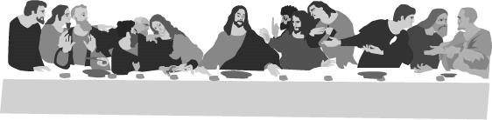
Congratulations to:
Eleanor Blashe - Brenna Gross - Jacob Hansen
Adam Pingel - Shane Skotzke
who will receive their First Holy Communion at tonight’s Passover Seder meal.

